Jira Jargon
Important terms and definitions

General
Issue – an individual item in Jira
Each time you create an item, you create a new issue with a unique key to identify it. An issue is any individual record in the Jira database.
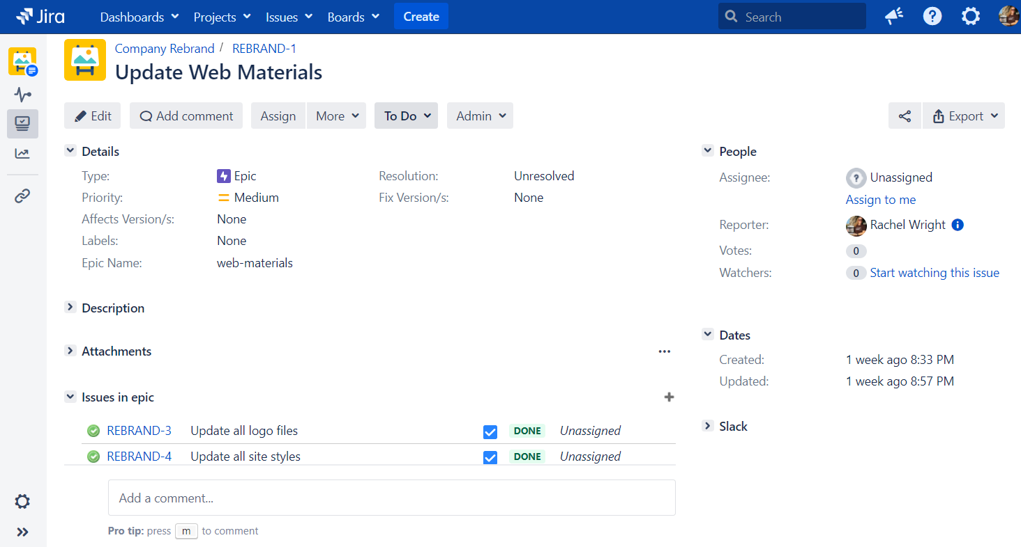

Project – a collection of Jira issues
The word “project” in Jira is different than an initiative your team is working on outside of Jira. Think of a Jira project as a container for all your team’s initiatives, tasks, and “to do” items. There is generally one Jira project per department, system, team, or application.
- Example: A Jira project called “Development” to track new features, bug fixes, and maintenance work.

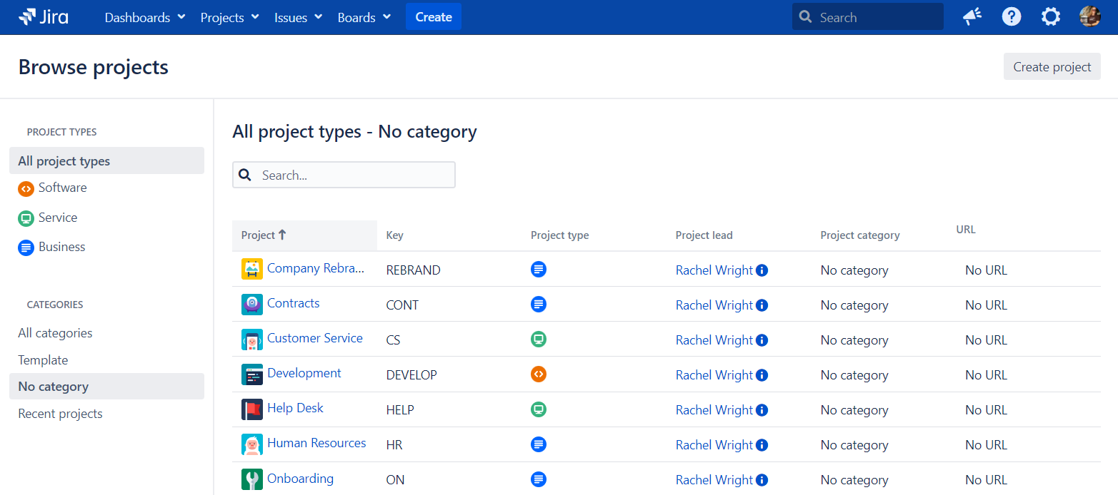
Issue type – a classification of issues in a Jira project
Examples: a request, a problem, a task, a “to do” item, a development item (like a Story, Bug, or Epic), or a support item (like a Change, Incident, or Service Request).

Development Project Example | Service Management Project Example
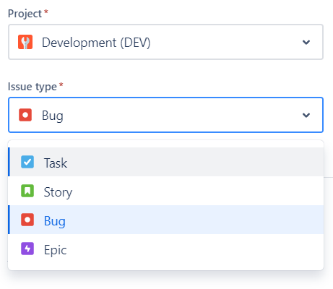 | 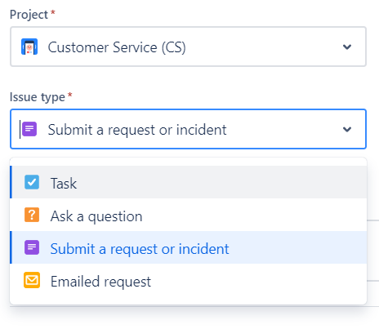

Search
Query – a question
A query is another word for a question. Each time you use a search engine, you’re querying the internet for web pages. When you search in Jira, you’re querying the database for issues that match your specifications.
- Example: How many bugs did the Marketing team report this year?
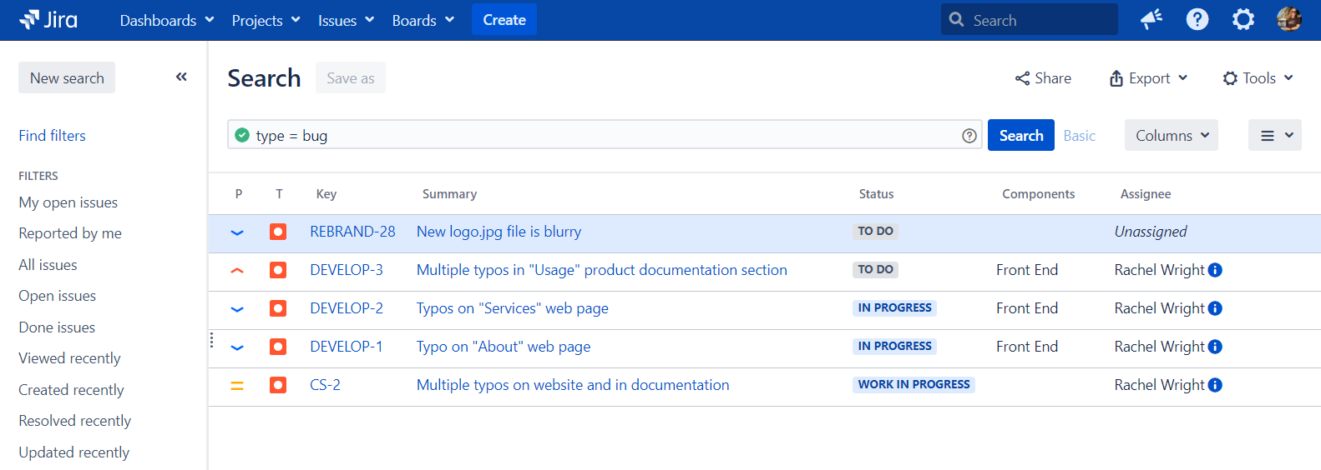
JQL – Jira Query Language
JQL is the way to search through thousands of issues to find the few you’re looking for. It’s also the way to control which issues appear on a board, and the data displayed on dashboards and in reports.
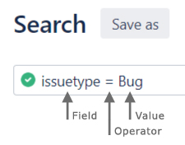

User Objects
Filter – a saved search result
Create a filter to reuse the search query again later.
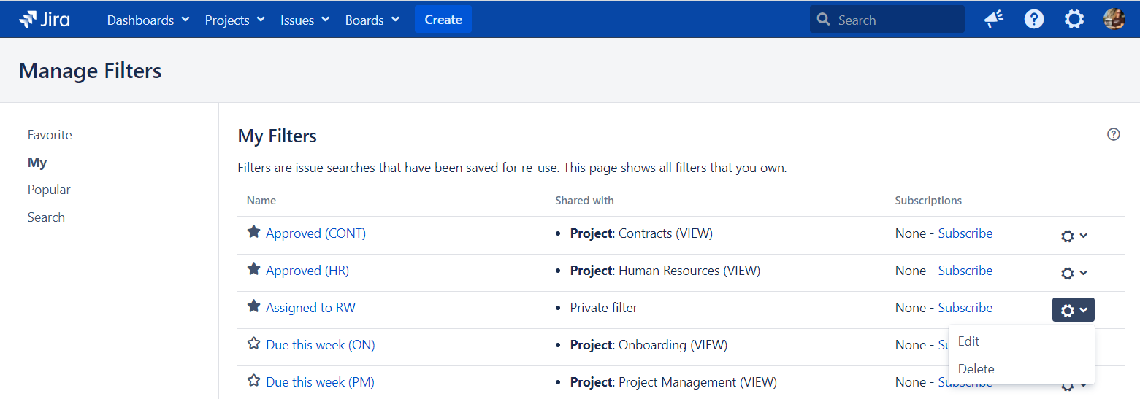

Filter subscription – search results by email
A filter subscription is a periodic notification of search results. Jira can send email about certain issues at a chosen frequency.
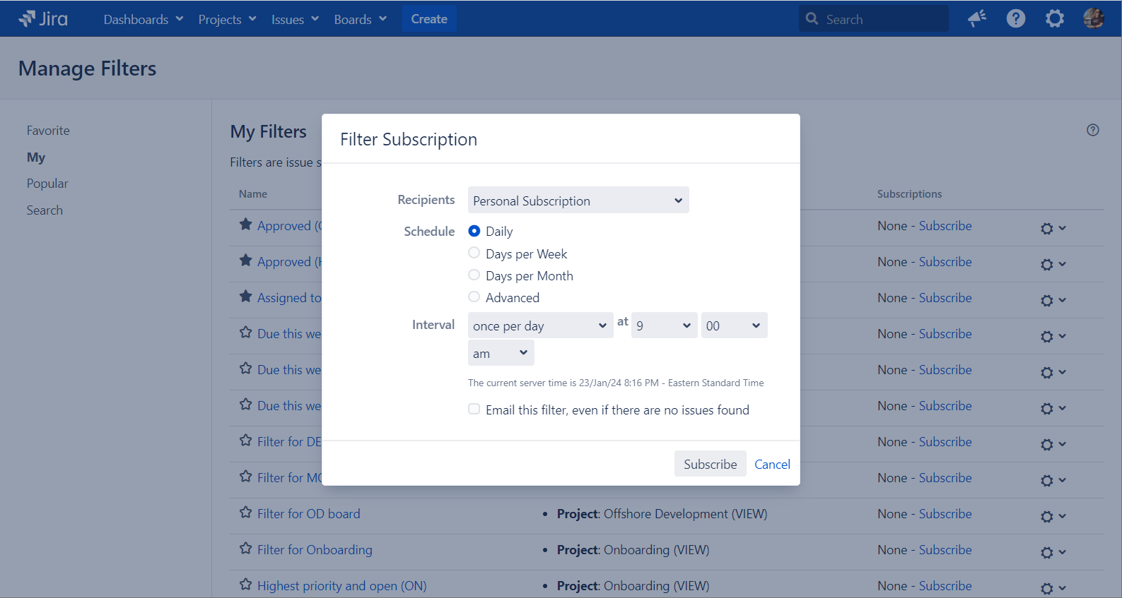
Queue – a shared view of issues
A queue is a unified view of work or a shared view of issues. They are used to segment and categorize requests in Jira Service Management.
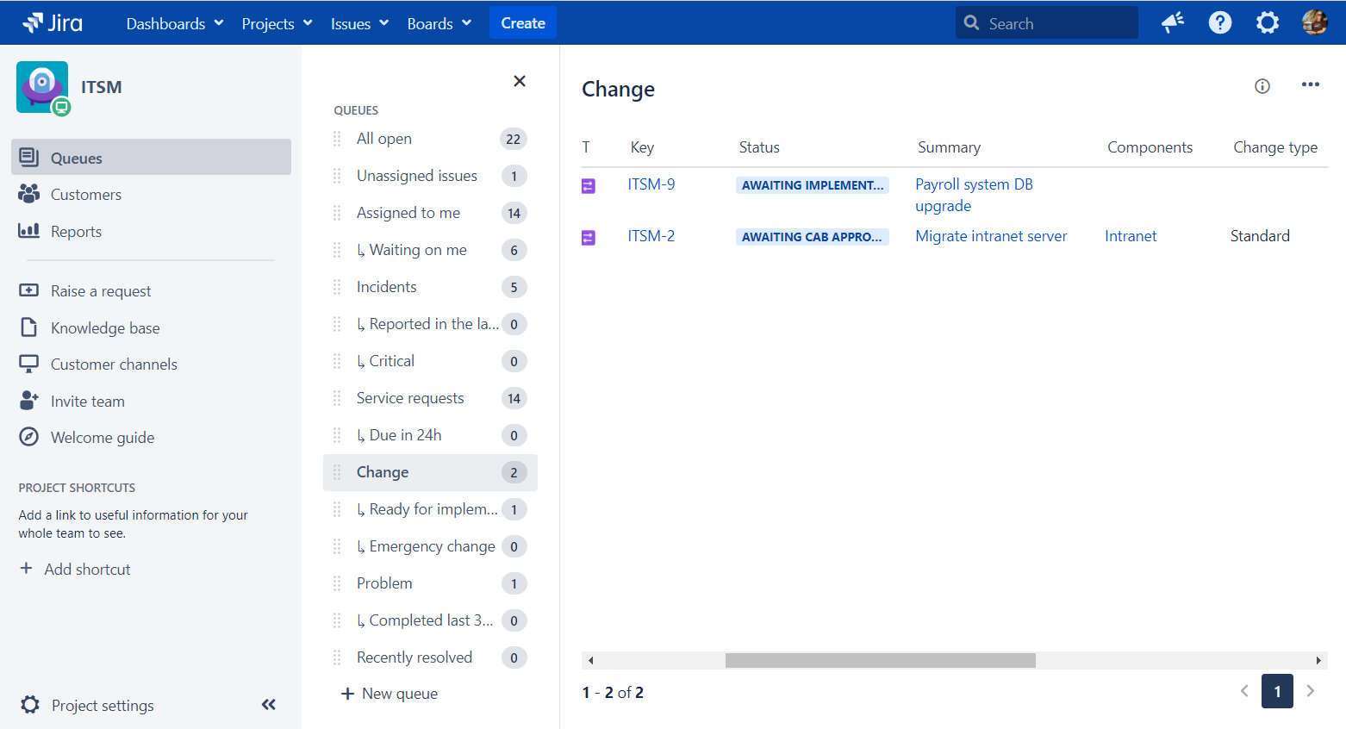

Board – a status-based view of issues
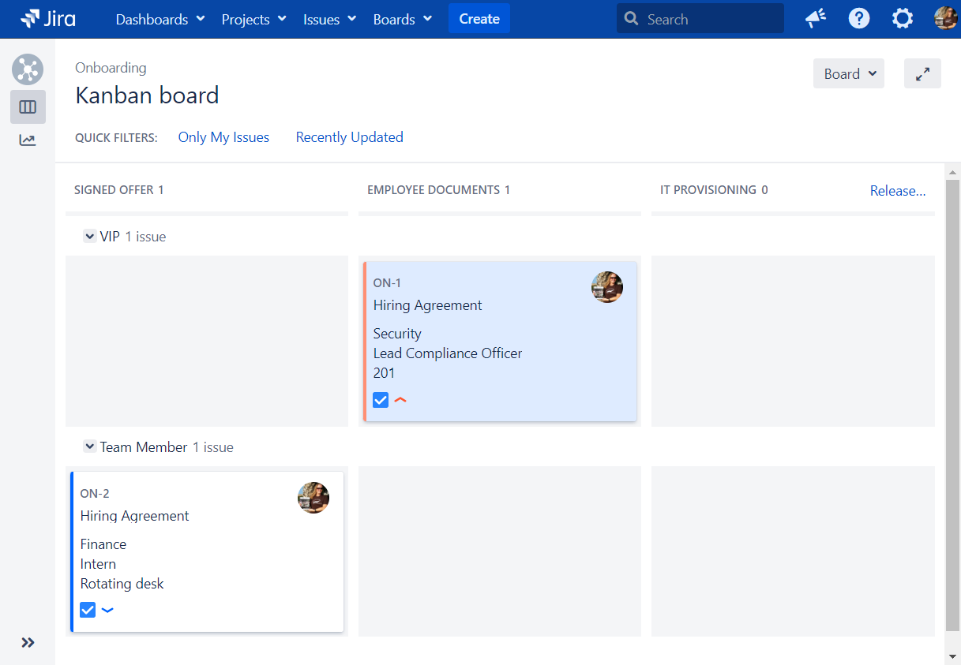
Scrum – work delivered at intervals
Scrum boards are for teams that deliver their work in regular, fixed intervals, called sprints. Example: Every 2 weeks

Kanban – work delivered continuously
Kanban boards are for teams with flexible delivery schedules.

Dashboard – a statistics-based view of issues
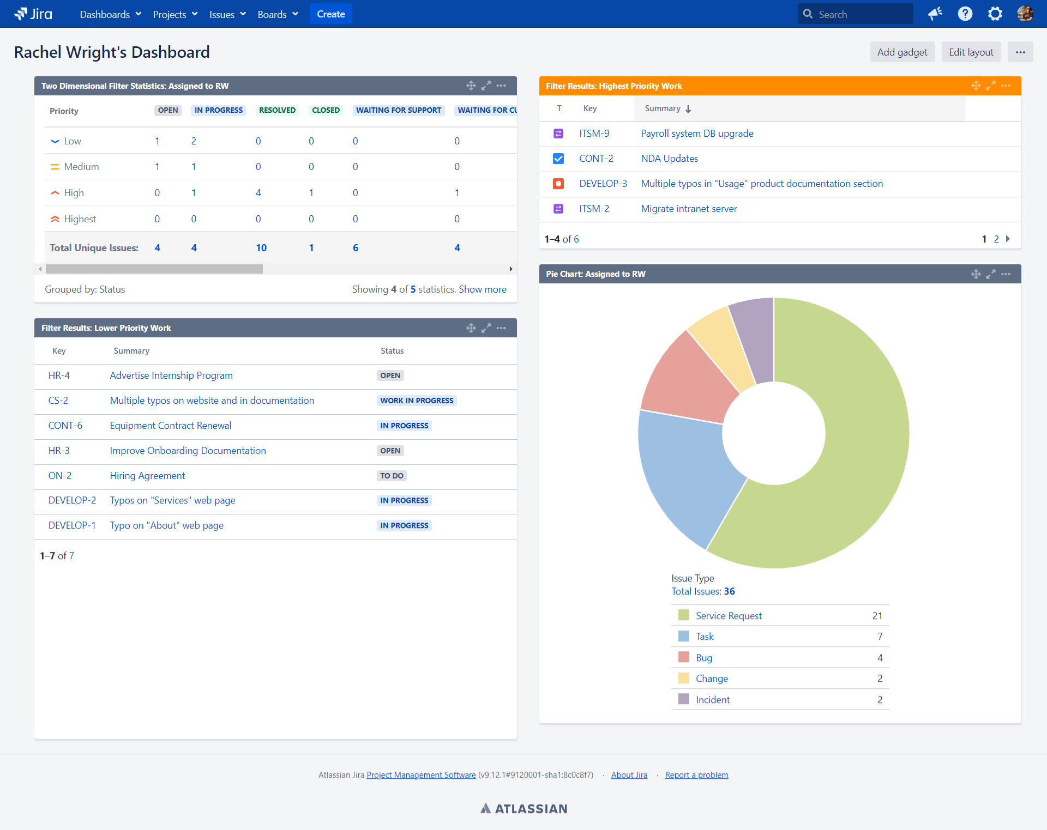

Gadget – dynamic dashboard content
A gadget is used to display dynamic content on a Jira dashboard. There are many different types of gadgets like charts, graphs, and lists.

Previous Terms
Before | After
Add-ons or plugins | Apps
Jira Service Desk (JSD) | Jira Service Management (JSM)
Epic Link | Parent

